**6.9 Group Problem Set: Similarity Word Problems**

*Each group member is responsible for drawing a picture and writing an explanation for the two problems on the page that they have.*

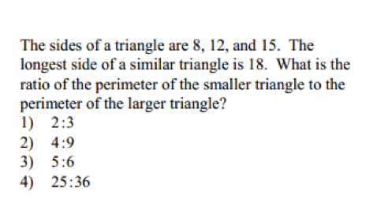

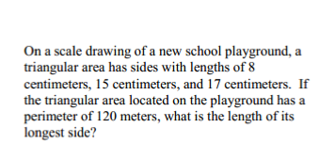

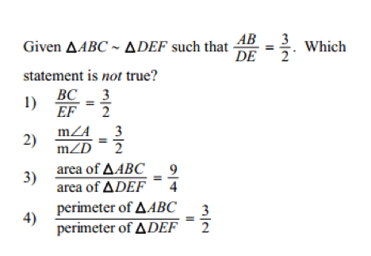

**6.9 Group Problem Set: Similarity Word Problems**

*Each group member is responsible for drawing a picture and writing an explanation for the two problems on the page that they have.*

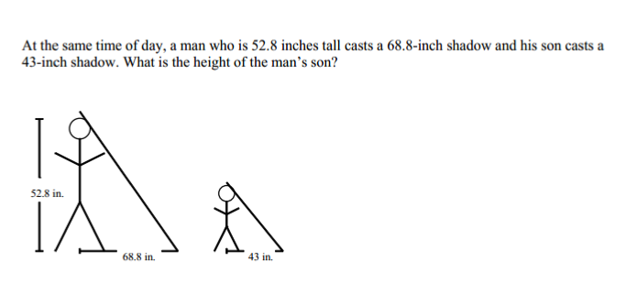

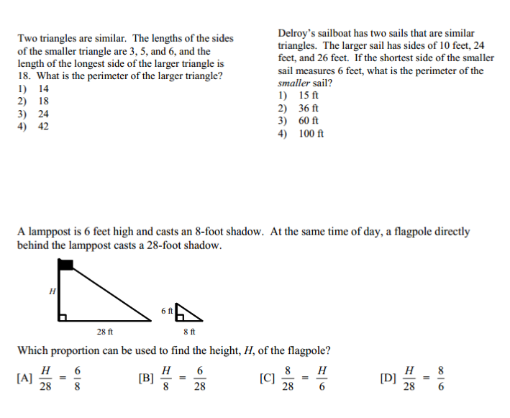



**6.9 Group Problem Set: Similarity Word Problems**

*Each group member is responsible for drawing a picture and writing an explanation for the two problems on the page that they have.*





**6.9 Group Problem Set: Similarity Word Problems**

*Each group member is responsible for drawing a picture and writing an explanation for the two problems on the page that they have.*

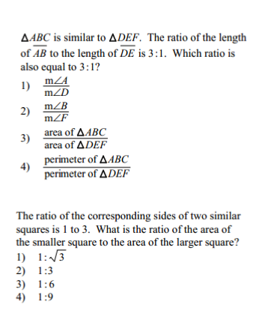



**6.9 Similar Triangle Word Problems HW**

*10 points*



1. Answer and explain your answer in space below:
2. Answer and explain your answer in the space below:
3. Answer and explain your answer in the space below:
4. Answer and explain your answer in the space below: